Code 4.4
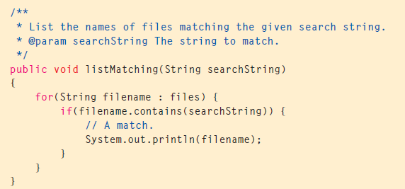
Exercise 4.25 Add the listMatching method in Code 4.4 to your version of the project. (Use music-organizer-v3 if you do not already have your own version.) Check that the method only lists matching files. Also try it with a search string that matches none of the file names. Is anything at all printed in this case?

Exercise 4.26 In listMatching, can you find a way to print a message, once the for-each loop has finished, if no file names matched the search string? Hint: Use a boolean local variable. Modify listMatching to accomplish this.

Exercise 4.27 Write a method in your version of the project that plays samples of all the tracks by a particular artist, one after the other. The listMatching method illustrates the basic structure you need for this method. Make sure that you choose an artist with more than one file. Use the playAndWait method of the MusicPlayer, rather than the startPlaying method; otherwise, you will end up playing all the matching tracks at the same time. The playAndWait method plays the beginning of a track (about 15 seconds) and then returns.

(Mr. Fadoir note: I recommend writing a method in the MusicOrganizer class called getArtist. The method should be private, take a filename as an parameter and return the name of the artist, assuming that the artist is located before the hyphen in the filename.)

